Task 3:

Agile in Jira (Scrum/Kanban Workflows) - 6 hour(s)
- Scrum Workflow in Jira: Sprints, Planning, and Execution.
- Estimating with Story Points and Time in Agile Projects.
- Running Daily Standups with Jira: Best Practices
- Working with Kanban: Managing Flow Over Time in Jira
- Visualizing Work with WIP Limits and Swimlanes in Jira
- Understanding the Cumulative Flow Diagram for Kanban Teams
- Bugs, lifecycle and their status updates

Scrum Workflow in Jira: Sprints, Planning, and Execution ::
Scrum is an agile framework where work is delivered in short fixed time intervals caled sprints.
Sprint Planning
The team selects prioritized stories from the backlog, estimates effort, and commits work to a sprint.
It controls : Scope control : Once sprint started, avoid adding work until its unavoidable.
Carry over : If story ins’t done in sprint, it can return to backlog for replanning.
Sprint Execution
Work is performed during the sprint, with issues moving across the board (To Do → In Progress → Done). Daily stand-ups help track progress and blockers.
Sprint Completion
At the end of the sprint, completed work is reviewed, and the sprint is closed. Jira reports (burndown, velocity) are used to assess performance.
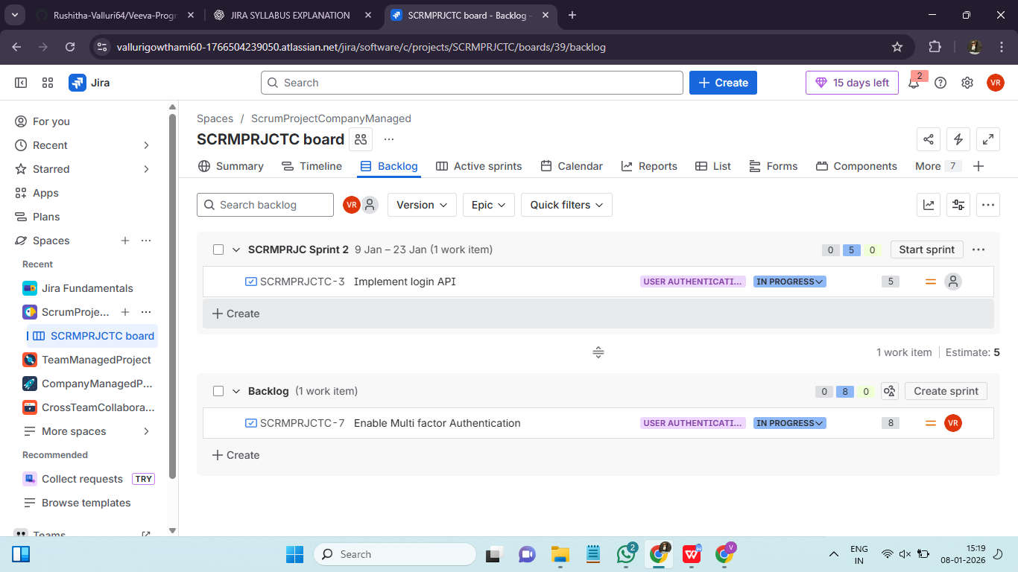

Estimating with Story Points and Time in Agile Projects ::
Estimation helps teams plan work, manage capacity, and set realistic delivery expectations. Agile teams commonly use story points and time-based estimates, each serving a different purpose.
- Story Points :
Story points estimate the relative effort of a user story by considering complexity, amount of work, risk, and uncertainty. They are assigned during backlog refinement or sprint planning and are used to calculate team velocity, which helps forecast future work. Teams estimate story points using:
- Relative Estimation Technique : Pick a reference story, compare new stories to it and assign points relatively.
- Velocity : Velocity is total story points completed in per sprint. It is used to predict furture sprint capacity.
- Time-Based Estimates :
Time estimates (hours or days) represent the expected effort required to complete tasks or subtasks. These are useful for day-to-day execution, workload balancing, and tracking remaining work during a sprint. It tracks actual working time.
Original estimate : Expected time.
Time spent : Actual time used.
Remaining estimate : Time left.
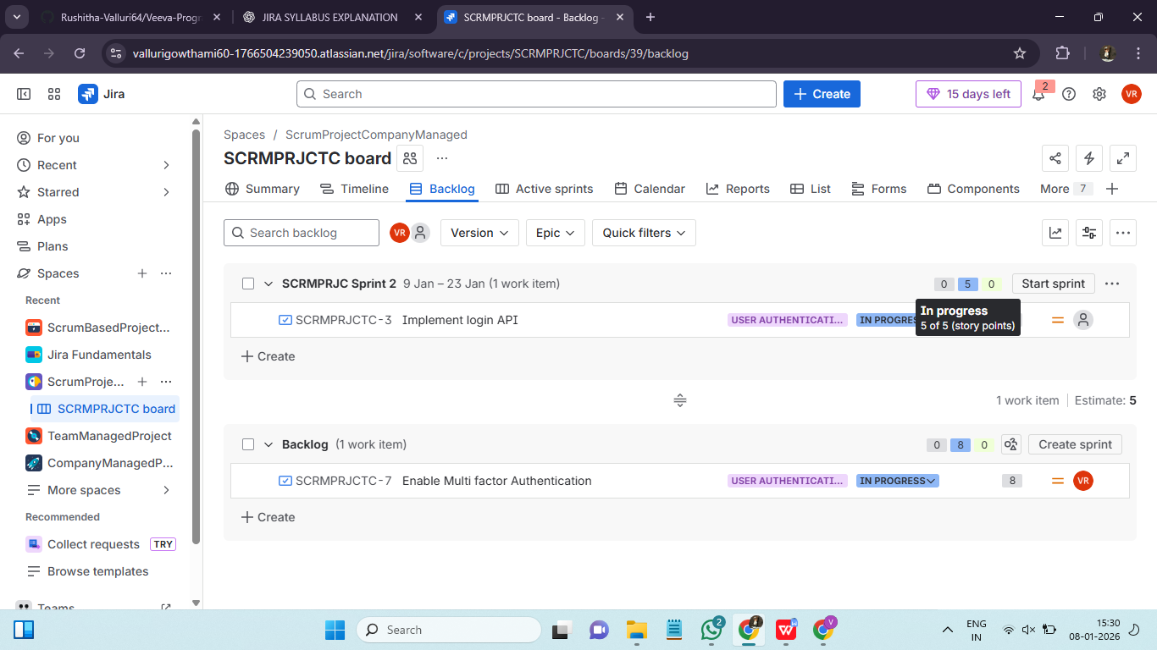

Running Daily Standups with Jira: Best Practices ::
Daily standups help teams align, identify blockers, and keep work moving. Jira supports effective standups by providing real-time visibility into work status. A daily standup is a short daily meeting(10-15 mins) where team synchronises work. It is a coordination meeting. Each team members answers :
- What did I do yesterday?
- What will I do today?
- Is anything blocking me?
Standup best practices with jira are:
- Board driven standups
- Use WIP awareness
- Use comments not memory

Working with Kanban: Managing Flow Over Time in Jira::
Kanban focuses on managing the continuous flow of work rather than working in fixed iterations. Jira’s Kanban boards help teams visualize work, limit overload, and improve delivery over time. Kanban follows 2 principles to manage flow day to day:
Principle 1: Pull, don’t push :- Start new work only when capacity is free. Finish existing work before starting new work.
Principle 2: Limit work in progress(WIP) :- Too much parallel work slows everything down, increases context switching.
Key kanban flow metrics :
- Cycle time: Time from inprogress to done.
- Lead time: Time from request to completion.
- Throughput: Numer of issues completed per time period.
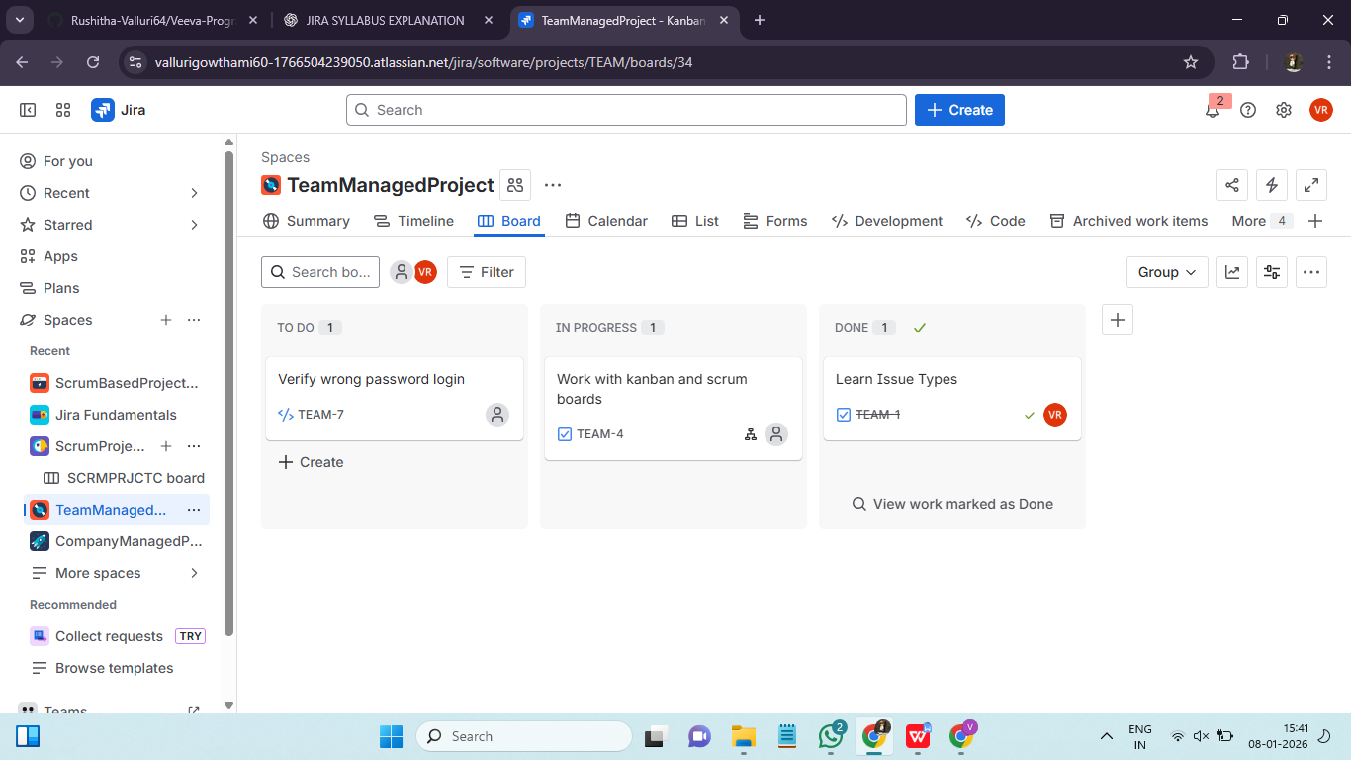

Visualizing Work with WIP Limits and Swimlanes in Jira ::
Jira helps teams manage work efficiently by visualizing tasks and controlling workflow.
Work in Progress (WIP) Limits :
Set maximum limits for tasks in each column to prevent overloading the team and maintain focus. WIP limits improve flow and help identify bottlenecks early.
Swimlanes :
Organize issues on the board into horizontal lanes based on criteria like assignee, priority, or epic. Swimlanes make it easier to see related work, group tasks, and track progress. Common swimlanes types are:
- By assignee : One lane per person
- By Epic : Progress per feature
- By priority : High priority on top and low on bottom
- By query
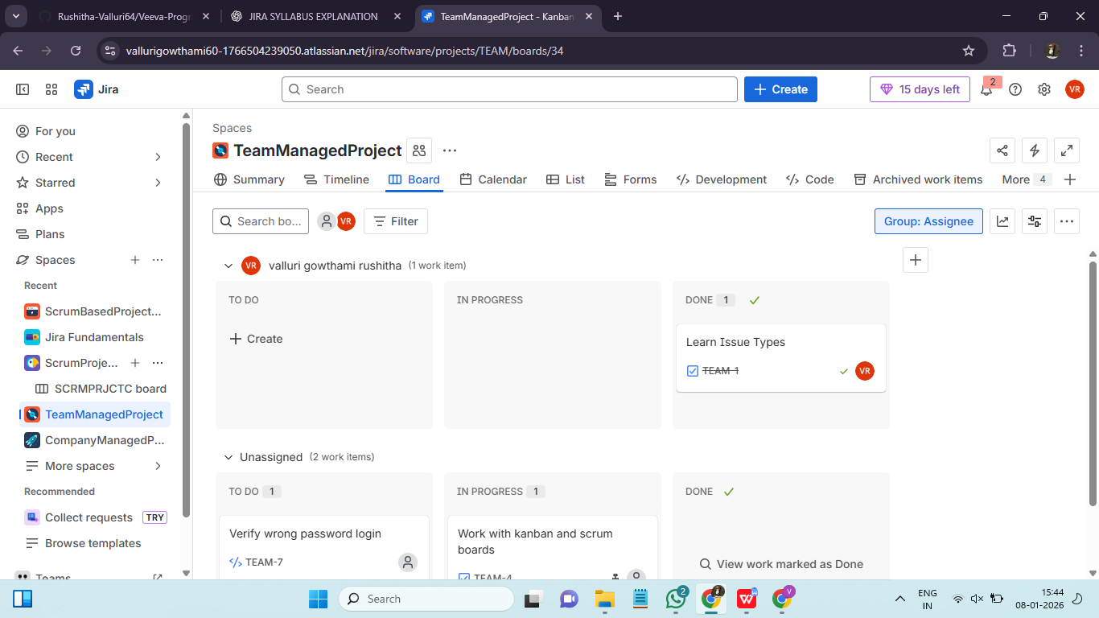

Understanding the Cumulative Flow Diagram (CFD) in Jira
Cumulative Flow Diagram is one of the most important kanban reports. It helps team to identify flow over time, identify bottlenecks and improve predictability. CFD is a visual report that shows how many issues are in each status and how that number changes over time.
Each color=status.
X axis : Time (days/weeks)
Y axis : Number of issues
CFD Rules :
- Top line slope:
Steep upward = work finishing fast
Flat= nothing getting done
- Thickness of a band:
Thick band=Work piling up
Thin band=Smooth flow
- Parallel bands :
Parallel=Stable process
Expanding band=Bottleneck
CFD helps to identify healthy flow, bottlencks, overloading. CFD shows metrics visually :
- Cycle time: Time from inprogress to done.
- Lead time: Time from request to completion.
- Throughput: Numer of issues completed per time period.
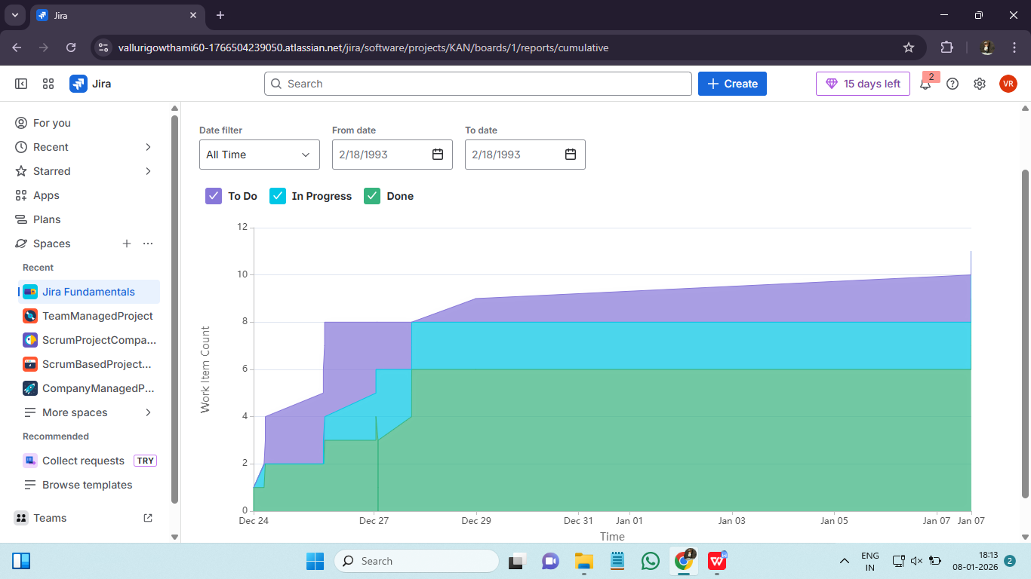

Bugs, Lifecycle, and Status Updates in Jira
Bugs are issues that represent defects, errors, or problems in software or processes. Managing their lifecycle ensures timely resolution and quality control.
Bug Lifecycle in Jira
- Open / New – Bug is reported and logged in Jira.
- In Progress – Assigned team member starts working on fixing the bug.
- In Review / Testing – Fix is implemented and submitted for code review or QA testing.
- Resolved / Fixed – Bug has been fixed; awaiting verification.
- Closed – QA verifies the fix; the bug is confirmed as resolved.
- Reopened – If the issue persists after verification, it is reopened for further work.
Status Updates
- Each status reflects the current stage of the bug in its lifecycle.
- Jira allows team members to update status, add comments, attach screenshots, and log work.
- Automated notifications can alert stakeholders about critical bug updates.

